# Gmail:rahulramasamy2026@gmail.com

# ID: 6388921

# GIT – Cognizant Hands-on Repository

GitHub: https://github.com/rahulRR007/Cognizant-Hands-on.git

## Task 1 – GitHub Config using Git Bash

git config --global user.name "Your Name"  
git config --global user.email [your_email@example.com](mailto:your_email@example.com)

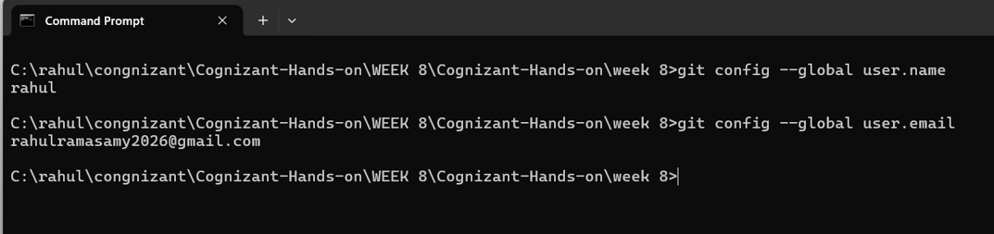

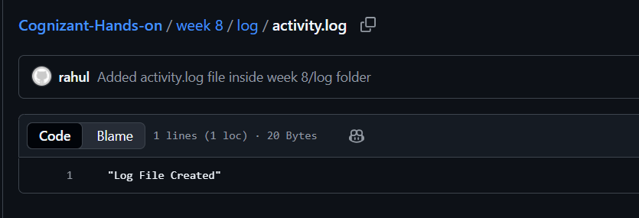

## Task 2 – Create a `.log` file and log folder

mkdir "week 8"  
cd "week 8"  
mkdir log  
echo "Log File Created" > log/activity.log  
git add log/activity.log  
git commit -m "Added activity.log file inside week 8/log folder"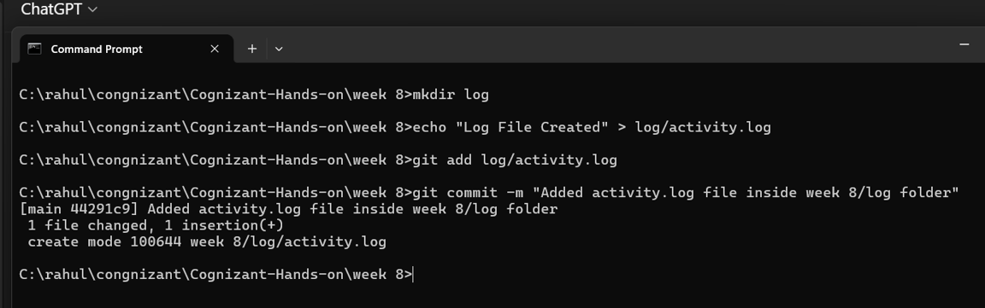

## Task 3 – Git Branching and Merging

git checkout -b feature-branch  
  
echo "Feature work in progress" > feature.txt  
git add feature.txt  
git commit -m "Added feature.txt"  
  
git checkout main  
git merge feature-branch

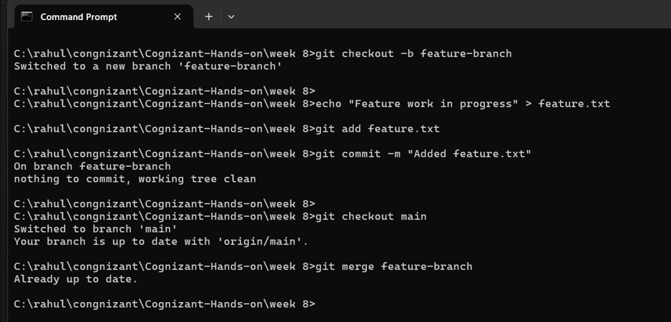

## Task 4 – Conflict Resolution

# On main branch  
echo "Main change" > conflict.txt  
git add conflict.txt  
git commit -m "Main branch change"  
  
# Create branch for conflict  
git checkout -b conflict-branch  
echo "Feature change" > conflict.txt  
git add conflict.txt  
git commit -m "Feature branch change"  
  
# Merge into main to cause conflict  
git checkout main  
git merge conflict-branch  
  
# Resolve conflict manually in conflict.txt, then:  
git add conflict.txt  
git commit -m "Resolved merge conflict"

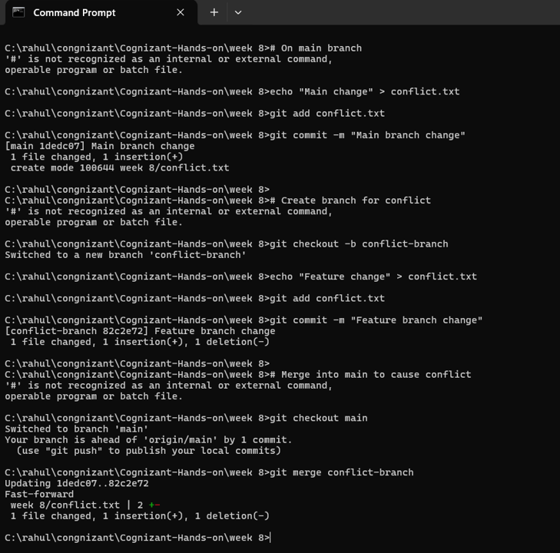

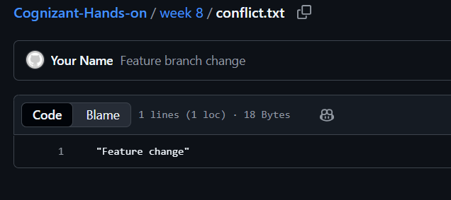

## Task 5 – Cleanup and Push

git branch -d feature-branch  
git branch -d conflict-branch  
  
git push origin main

